BOC API Document
Quoted – Awaiting Customer PO
“Approve”:
- /api/v1.0/address/list
- /api/v1.0/CustomerBlanketPO/BlanketPOListByCustomerId

- “/api/v1.0/address/list”: Repeated
- “/api/v1.0/CustomerBlanketPO/BlanketPOListByCustomerId”
Open “Front End” codebase”:
Search the API in “restURI.ts” file:
Copy: “ByCustomerBlanketPOList” to search in frontend.
Open “Back End” codebase:
Open “customer.blanket.po.routes.js”,
“Right” click on “CustomerBlanketPO.BlanketPOListByCustomerId” in line 19, click “Go to Definition”, it shows the code in “customer.blanket.po.controller.js”,
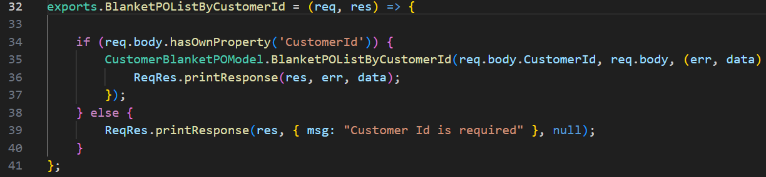
“Right” click on “BlanketPOListByCustomerId” in line 35, click “Go to Definition”, it shows its “SQL” codebase in “repair.request.vendors.model.js” in line 295,
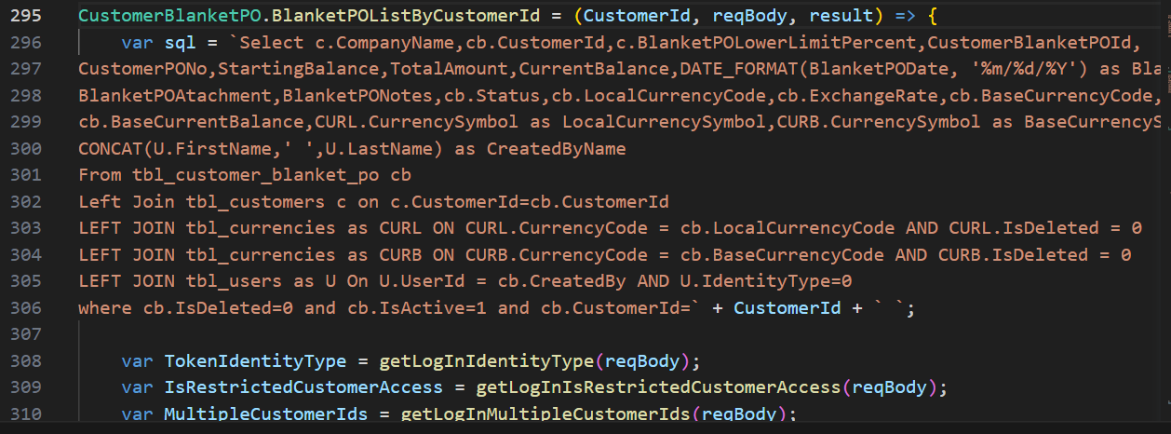
and so on.

“Reject”:
- /api/v1.0/quotes/rejectCustomerQuote
- /api/v1.0/notification/getLatest
- /api/v1.0/repairRequest/WorkchainMyTaskCount
- /api/v1.0/ecommerce/product/cartCount
- /api/v1.0/country/list
- /api/v1.0/repairRequest/view
- /users/getAllActiveAdmin
- /api/v1.0/RRSubStatus/dropdown
- /api/v1.0/currencyExchangeRate/exchange
- /api/v1.0/address/GetAHGroupVendorAddress

- “/api/v1.0/quotes/rejectCustomerQuote”
Open “Front End” codebase”:
Search the API in “restURI.ts” file:
Copy: “RRCustomerQuoteReject” to search in frontend.
Open “Back End” codebase:
Open “quotes.routes.js”,
“Right” click on “quotes.rejectCustomerQuote” in line 24, click “Go to Definition”, it shows the code in “quotes.controller.js”,
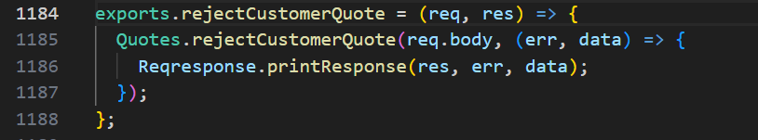
“Right” click on “rejectCustomerQuote” in line 1185, click “Go to Definition”, it shows its “SQL” codebase in “quotes.model.js” in line 1289,
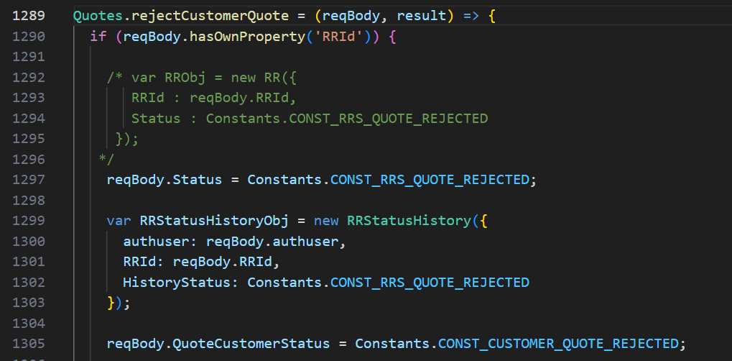
and so on.

- “/api/v1.0/notification/getLatest”: Repeated
- “/api/v1.0/repairRequest/WorkchainMyTaskCount” : Repeated
- “/api/v1.0/ecommerce/product/cartCount” : Repeated
- “/api/v1.0/country/list” : Repeated
- “/api/v1.0/repairRequest/view” : Repeated
- “/users/getAllActiveAdmin” : Repeated
- “/api/v1.0/RRSubStatus/dropdown” : Repeated
- “/api/v1.0/currencyExchangeRate/exchange” : Repeated
- “/api/v1.0/address/GetAHGroupVendorAddress” : Repeated

“Submit”:
- /api/v1.0/quotes/approveCustomerQuote
- /api/v1.0/notification/getLatest
- /api/v1.0/repairRequest/WorkchainMyTaskCount
- /api/v1.0/ecommerce/product/cartCount
- /api/v1.0/country/list
- /api/v1.0/repairRequest/view
- /users/getAllActiveAdmin
- /api/v1.0/RRSubStatus/dropdown
- /api/v1.0/invoice/listPartsLPP
- /api/v1.0/currencyExchangeRate/exchange

- “/api/v1.0/quotes/approveCustomerQuote”
Open “Front End” codebase”:
Search the API in “restURI.ts” file:
Copy: “RRCustomerQuoteApprove” to search in frontend.
Open “Back End” codebase:
Open “quotes.routes.js”,
“Right” click on “quotes.approveCustomerQuote” in line 22, click “Go to Definition”, it shows the code in “quotes.controller.js”,
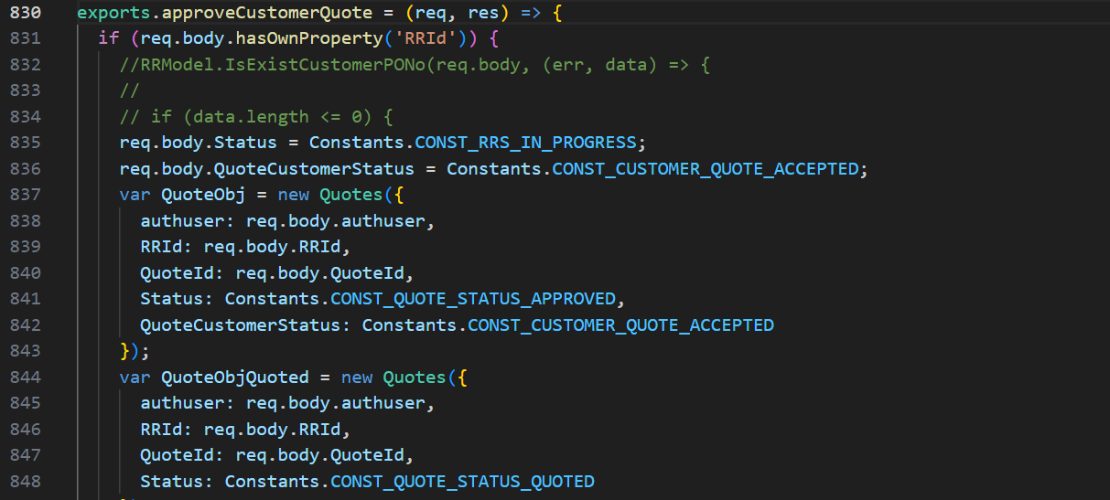
and so on…
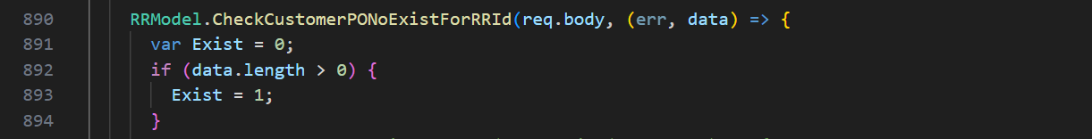
and so on…
“Right” click on “CheckCustomerPONoExistForRRId” in line 890, click “Go to Definition”, it shows its “SQL” codebase in “repair.request.model.js” in line 143,
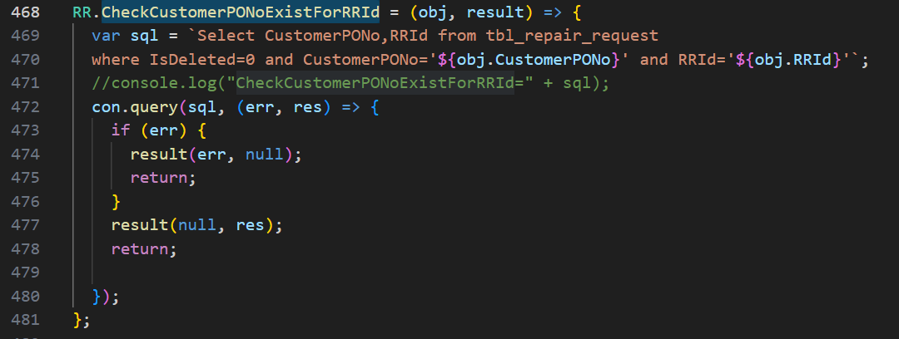

- “/api/v1.0/notification/getLatest”: Repeated
- “/api/v1.0/repairRequest/WorkchainMyTaskCount” : Repeated
- “/api/v1.0/ecommerce/product/cartCount” : Repeated
- “/api/v1.0/country/list” : Repeated
- “/api/v1.0/repairRequest/view” : Repeated
- “/users/getAllActiveAdmin” : Repeated
- “/api/v1.0/RRSubStatus/dropdown” : Repeated
- “/api/v1.0/currencyExchangeRate/exchange” : Repeated

